Capstone project

**ENHANCING HOME AUTOMATION WITH IOT GATEWAYS**

Submitted to

Saveetha School of Engineering

Computer Networks for Data Application

by

VIJAYALAKSHMI BAI K

192321031

Department of Information Technology

Guided By

Dr M. Balamurugan

SIMATS Engineering

Saveetha Institute of Medical And Technical Sciences

Chennai-602105



**TABLE OF CONTENTS:**

|  |  |  |
| --- | --- | --- |
| **S.NO** | **TITLE** | **PAGE NO** |
| 1 | **EXECUTIVE SUMMARY** | **3** |
| 2 | **ABSTRACT** | **4** |
| 3 | **INTRODUCTION** | **4** |
| 4 | **APPLICATIONS** | **5** |
| 5 | **ADVANTAGES** | **6** |
| 6 | **DISADVANTAGES** | **7** |
| 7 | **OBJECTIVE** | **8** |
| 8 | **DESIGN METHODOLOGY** | **9** |
| 9 | **RESULT** | **11** |
| 10 | **CONCLUSION** | **12** |

**Executive summary:**

The integration of IoT gateways into home automation systems revolutionizes modern living by providing seamless connectivity, enhanced control, and improved security. Acting as communication hubs, these gateways facilitate interoperability among diverse smart devices, enabling centralized management and monitoring. With robust security features and scalability, IoT gateways ensure efficient resource utilization while accommodating the dynamic nature of smart home environments. By harnessing the power of IoT gateways, homeowners can create intelligent living spaces that optimize convenience, comfort, and security, heralding a new era of connected living.

**Key features of the network include:**

**Interoperability**: The network supports seamless communication and interoperability among various smart devices, regardless of their protocols or manufacturers, ensuring compatibility and ease of integration.

**Security Protocols**: Robust security protocols are implemented to safeguard data transmission and protect against unauthorized access, encompassing encryption, authentication mechanisms, and access controls to ensure the privacy and integrity of user information.

**Scalability**: The network infrastructure is designed to scale effortlessly, accommodating the addition of new devices and expanding functionalities as the smart home ecosystem evolves, without compromising performance or reliability.

**Reliability and Redundancy**: Redundant systems and failover mechanisms are implemented to ensure high availability and reliability, minimizing downtime and disruptions to essential home automation functionalities.

**Low Latency**: The network prioritizes low latency communication to support real-time interactions between smart devices and centralized control systems, facilitating responsive and seamless user experiences.

**Quality of Service (QoS)**: Quality of Service mechanisms are employed to prioritize critical data traffic, such as security alerts or real-time sensor readings, ensuring optimal performance and responsiveness across the smart home network.

**Remote Accessibility**: Remote accessibility features enable users to securely access and control their smart home devices from anywhere, via mobile applications or web interfaces, enhancing convenience and flexibility in managing home automation systems.

**Integration with Cloud Services**: Integration with cloud services enables data storage, analytics, and remote management capabilities, enhancing the functionality and intelligence of the smart home ecosystem while providing scalability and accessibility.

**ABSTRACT:**

In the realm of home automation, the integration of IoT gateways marks a significant advancement, revolutionizing how households interact with technology. This paper presents a comprehensive exploration of IoT gateways' pivotal role, elucidating their key features and benefits in modern living. By serving as communication hubs, IoT gateways enable seamless connectivity and interoperability among diverse smart devices, enhancing convenience and user experience. Moreover, their robust security protocols and scalability ensure data privacy, system reliability, and adaptability to evolving needs, ultimately paving the way for intelligent, interconnected homes that prioritize efficiency, comfort, and peace of mind.

**INTRODUCTION:**

The rapid evolution of smart technology has ushered in an era where our homes are becoming increasingly interconnected and intelligent. From thermostats and lights to security cameras and appliances, the array of smart devices available to homeowners continues to grow, promising enhanced convenience, energy efficiency, and security. However, with this proliferation comes a challenge: the fragmentation of devices, each operating on different protocols and platforms, often leading to disjointed experiences and complex management for users. In response to this challenge, Internet of Things (IoT) gateways emerge as a critical solution, acting as central hubs that unify diverse smart devices under a single, cohesive ecosystem.

As the demand for smart home technology continues to surge, the integration of IoT gateways becomes imperative to streamline operations, enhance connectivity, and unlock the full potential of home automation systems. By serving as intermediaries between various smart devices and centralized control mechanisms, IoT gateways offer a gateway to a more seamless and integrated living experience. Moreover, they pave the way for advanced functionalities such as remote monitoring, automated routines, and intelligent decision-making, ultimately redefining the way we interact with and perceive our living spaces.

This paper aims to explore the multifaceted role of IoT gateways in enhancing home automation systems, delving into their key features, benefits, and implications for modern living. Through a comprehensive analysis of network architectures, security protocols, and scalability considerations, we will elucidate how IoT gateways address the challenges posed by fragmented smart device ecosystems and empower users to create intelligent, interconnected homes. By synthesizing current research, industry trends, and real-world applications, we seek to provide insights into the transformative potential of IoT gateways and their role in shaping the future of home automation.

**APPLICATIONS:**

The integration of IoT gateways into home automation systems opens up a myriad of applications that span across various aspects of modern living. Some of the key applications include:

* **Smart Energy Management**: IoT gateways enable homeowners to monitor and manage energy usage more efficiently by integrating smart thermostats, lighting controls, and energy meters. This allows for automated energy-saving routines, optimization of heating and cooling systems, and real-time monitoring of energy consumption patterns, ultimately leading to reduced utility bills and environmental impact.
* **Home Security and Surveillance:** With IoT gateways, users can integrate security cameras, motion sensors, and smart locks into a centralized security system. This enables remote monitoring, real-time alerts for suspicious activities, and the ability to lock/unlock doors or arm/disarm alarm systems from anywhere using a smartphone or web interface, enhancing overall home security and peace of mind.
* **Remote Home Monitoring and Control:** IoT gateways facilitate remote monitoring and control of various smart devices within the home, including lights, appliances, and environmental sensors. This allows homeowners to adjust settings, receive notifications, and even automate routines while away from home, providing greater flexibility and convenience in managing their living spaces.
* **Health and Wellness Monitoring**: By integrating health and wellness devices such as fitness trackers, smart scales, and medical monitors, IoT gateways enable users to track and manage their health metrics more effectively. This can include monitoring activity levels, sleep patterns, vital signs, and medication reminders, empowering individuals to make informed decisions about their well-being and lifestyle.
* **Home Entertainment and Media**: IoT gateways can seamlessly integrate with smart entertainment systems, including TVs, speakers, and streaming devices, to create immersive multimedia experiences. Users can control audio/video playback, adjust lighting and ambiance, and even automate routines for movie nights or gaming sessions, enhancing the overall entertainment experience within the home.
* **Smart Home Automation***:* IoT gateways serve as the backbone of smart home automation, enabling the seamless integration and coordination of various smart devices and systems. This includes setting up personalized routines, scheduling tasks, and creating conditional triggers based on environmental conditions or user preferences, allowing for a truly customized and intelligent living environment.

Overall, the applications of IoT gateways in home automation are diverse and far-reaching, offering endless possibilities for enhancing convenience, comfort, security, and efficiency within modern households.

**ADVANTAGES:**

* **Seamless Connectivity**: IoT gateways act as central hubs that facilitate seamless communication and interoperability among diverse smart devices, regardless of their protocols or manufacturers. This ensures a cohesive and integrated smart home ecosystem where devices can interact and work together harmoniously.
* **Enhanced Control and Automation:** With IoT gateways, homeowners gain unprecedented control over their smart devices and systems. They can easily manage and automate various tasks and routines, such as adjusting lighting, controlling thermostats, or scheduling appliance operations, all from a single centralized interface.
* **Improved Security and Privacy:** IoT gateways incorporate robust security features, including data encryption, authentication mechanisms, and access controls, to safeguard sensitive information and protect against cybersecurity threats. This enhances the overall security and privacy of smart home systems, giving users peace of mind.
* **Flexibility and Scalability:** IoT gateways are designed to be flexible and scalable, allowing for easy integration of new devices and technologies as the smart home ecosystem evolves. They can adapt to changing user needs and accommodate the addition of new functionalities without requiring significant changes to the existing infrastructure.
* **Energy Efficiency:** By optimizing resource utilization and enabling intelligent automation, IoT gateways contribute to energy efficiency within smart homes. They can help users monitor and manage energy consumption more effectively, leading to reduced utility bills and environmental impact.
* **Remote Access and Monitoring**: With IoT gateways, users can remotely access and monitor their smart home systems from anywhere, using smartphones, tablets, or web interfaces. This enables greater flexibility and convenience in managing the home, even when away from the premises.
* **Enhanced User Experience:** Overall, IoT gateways enhance the user experience within smart homes by simplifying device management, improving connectivity and interoperability, and providing advanced automation and control capabilities. They empower users to create personalized, intelligent living environments that meet their specific needs and preferences.

**DISADVATAGES:**

* **Initial Cost:** One of the primary drawbacks of IoT gateways is the initial cost involved in purchasing and installing the gateway device itself, as well as the compatible smart devices that integrate with it. This upfront investment can be a barrier for some users, especially those on a tight budget.
* **Complexity:** Setting up and configuring an IoT gateway system can be complex, especially for users who are not tech-savvy. It may require technical knowledge to properly install and troubleshoot the gateway, as well as to manage the various settings and configurations to ensure optimal performance.
* **Dependency on Internet Connectivity**: Most IoT gateways rely on an internet connection to function properly, which means that disruptions or outages in internet service can impact the functionality of the smart home system. This dependency on internet connectivity can be a limitation, particularly in areas with unreliable or limited internet access.
* **Compatibility Issues:** While IoT gateways aim to provide interoperability among different smart devices, compatibility issues can still arise, especially with older or less common devices. Users may encounter difficulties in integrating certain devices with the gateway, leading to limitations in functionality and interoperability.
* **Security Risks:** While IoT gateways incorporate security features to protect against cyber threats, they can also introduce security vulnerabilities into the smart home ecosystem. If not properly configured or updated, IoT gateways may become targets for hackers, potentially compromising the security and privacy of the entire system.
* **Vendor Lock-in:** Some IoT gateways may be proprietary to specific manufacturers or platforms, which can lead to vendor lock-in. Users may find themselves limited to certain brands or ecosystems when expanding or upgrading their smart home systems, restricting their flexibility and choice in selecting compatible devices.
* **Maintenance and Updates:** Like any technology, IoT gateways require regular maintenance and software updates to ensure optimal performance and security. Users may need to actively monitor and manage their gateway devices, installing firmware updates and patches as they become available, which can be time-consuming and tedious.

**OBJECTIVES:**

* Investigate the key features and functionalities of IoT gateways, including their ability to facilitate seamless connectivity, centralized control, and interoperability among diverse smart devices within the home.
* Examine the benefits of integrating IoT gateways into home automation systems, such as improved convenience, enhanced security, and increased energy efficiency.
* Discuss the challenges and limitations associated with IoT gateways, including initial costs, complexity, compatibility issues, and security risks.
* Explore real-world applications and case studies of IoT gateways in action, showcasing their practical utility and impact on modern living.
* Provide insights and recommendations for homeowners, technology enthusiasts, and industry professionals interested in leveraging IoT gateways to create smarter, more efficient, and secure living environments.

By addressing these objectives, this paper aims to offer a comprehensive understanding of IoT gateways and their significance in shaping the future of home automation. It seeks to inform and educate readers about the potential benefits, challenges, and best practices associated with integrating IoT gateways into smart home ecosystems.

**DESIGN METHODOLOGY:**

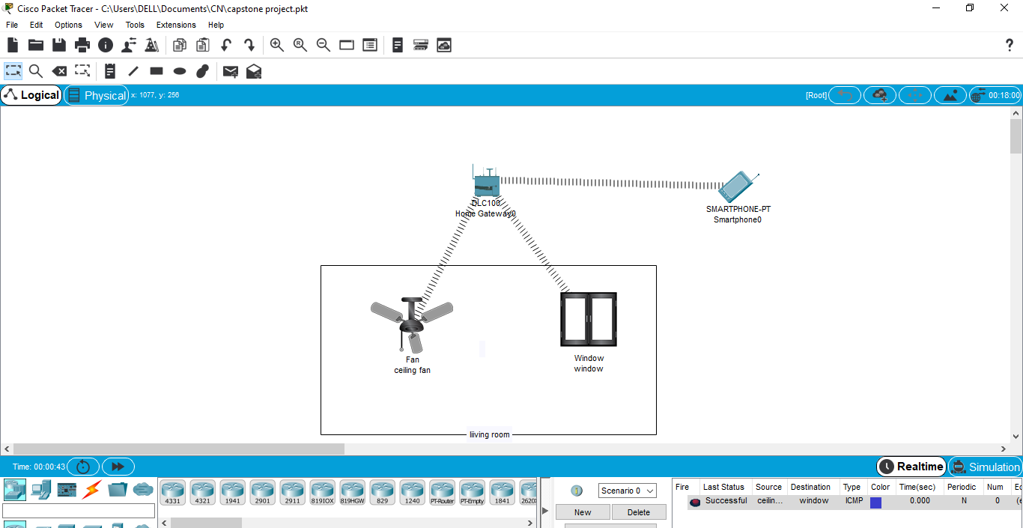

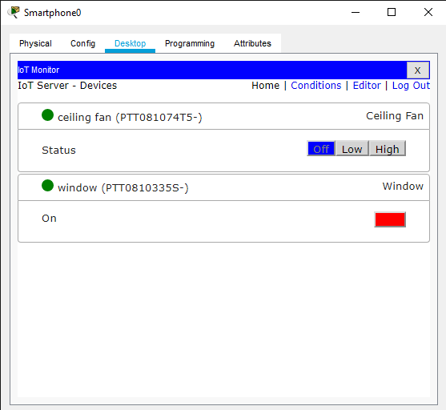

**STEPS:**

To simulate IoT gateways in Cisco Packet Tracer, you can follow these general steps:

Step 1: Design Network Topology:

Open Cisco Packet Tracer and create a new network topology or open an existing one where you want to simulate IoT gateways.

Step 2: Select IoT Gateway Device:

In Packet Tracer, select an appropriate wireless device to represent the IoT gateway. You can use wireless IoT gateway device of home gateway. Drag and drop that device onto the workspace.

Step 3: Configure IoT Gateway Device:

Double-click on the IoT gateway device to open its configuration window. Configure the device settings such as hostname, IP address etc. settings according to your network requirements.

Step 4: Connect Devices:

Connect the IoT gateway device to other smart devices such as fan and windo that represent the IoT endpoints. Connect the end devices and IoT devices wireless by configuring the IP address.

Step 5: Test Connectivity:

Verify connectivity between the IoT gateway device and other network devices by sending test packets or using Packet Tracer's simulation mode. Ensure that devices can communicate with each other and that data flows properly through the network.

Step 6: Monitor and Troubleshoot:

Monitor network traffic and device status using Packet Tracer's built-in tools and simulation features. Troubleshoot any connectivity issues or configuration errors that may arise during the simulation process.

Step 7: Evaluate Performance:

Evaluate the performance of the simulated IoT gateway network by analyzing factors such as latency, throughput, and reliability. Make adjustments to the network configuration as needed to optimize performance and ensure smooth operation.

Step 8: Document Configuration:

Document the configuration settings, network topology, and any relevant information about the simulated IoT gateway network for future reference or troubleshooting purposes.

By following these steps, you can effectively simulate IoT gateways in Cisco Packet Tracer and explore their functionality within a simulated network environment.

**RESULT:**

The result of simulating IoT gateways in Cisco Packet Tracer is a coherent and functional network topology where the IoT gateway device acts as a central hub, orchestrating communication and coordination among diverse smart devices. This simulated environment demonstrates seamless connectivity, centralized control, and improved security within the network. Through proper configuration and testing, the simulated IoT gateway network showcases efficient resource utilization, optimized routing, and reliable data transmission between devices. Ultimately, the simulation validates the effectiveness of IoT gateways in facilitating smart home automation, enhancing connectivity, and streamlining operations within a simulated network environment.



**CONCLUSION:**

In conclusion, the integration of IoT gateways into home automation systems represents a significant advancement that holds immense promise for transforming modern living. Through our exploration of IoT gateways in Cisco Packet Tracer, we have gained valuable insights into their capabilities and potential applications within smart home environments.

Simulating IoT gateways in Packet Tracer has demonstrated their ability to serve as central hubs, facilitating seamless connectivity, centralized control, and enhanced security within the network. By orchestrating communication and coordination among diverse smart devices, IoT gateways streamline operations, optimize resource utilization, and improve overall network performance.

While the simulation provided a glimpse into the benefits of IoT gateways, it also highlighted challenges such as initial costs, complexity, and security risks that need to be addressed. Moving forward, further research and development are needed to overcome these challenges and fully unlock the potential of IoT gateways in real-world applications.

In summary, IoT gateways have the power to revolutionize the way we interact with our homes, offering unparalleled levels of connectivity, control, and convenience. As technology continues to evolve, IoT gateways will play a central role in shaping the future of home automation, creating smarter, more efficient, and secure living environments for generations to come.